Wigmore Group Parish Council
Clerk: Linda Henry – 01584 878865 Linda-henry@live.co.uk

The next meeting of Wigmore Group Parish is at 8pm on
Monday, 8th June 2015 in Wigmore Village Hall
There will be an opportunity for members of the public to speak
at the beginning of the meeting.

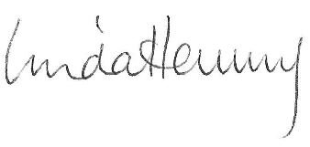 | Parish Clerk, 1 June 2015
A G E N D A
1 | To record those present and receive apologies for absence.
2 | To receive declarations of interest & agree dispensations as appropriate.
3 | To co-opt new parish councillors to fill vacancies following the election
4 | To welcome and receive reports/information from:  3.1 County Councillor – Carole Gandy  3.2 Rachel Dixon, Locality Steward
5 | Minutes: To confirm the minutes of the meeting held 11/5/15
6 | Lengthsman Scheme – update
7 | Use of Community Field – proposal to hold Sunday League football matches
8 | To receive update on matters previously considered:  - Wigmore noticeboards - repair  - Defibrillator – update  - Village litter pick  - Millennium Green - refurbishment
9  10 | Regular items  - Neighbourhood Plan  - Mortimer News & Website  - Traffic calming options  Transparency Code – new regulations for publication of Parish Council information and to consider retaining services for update of website.
11 | Finance  To agree payments  - in accordance with the budget  - under the terms of the Lengthsman Scheme
12 | Planning applications:  (a) 151270 - Land at Burnt House, Castle Street, Wigmore, HR6 9VA, Herefordshire HR6 9VA – Proposed demolition of an outbuilding & erection of single detached dwelling.  - Any updates - tbc
13 | Correspondence: to receive correspondence and reply as necessary
14 | Date of following meeting – Monday 13 July 2015

