West Mercia Police
Leominster
Safer Neighbourhood Team (SNT)
Leominster.snt@westmercia.pnn.police.uk
August 2016

About your team:

Safer Neighbourhood Teams work with local people and partners to identify, tackle and solve issues that matter to the community where you live.

Making neighbourhoods safer by cutting day to day crime and anti-social behaviour is at the heart of keeping people in West Mercia safe. Thanks to an investment in mobile tablet style computers, these will enable officers to spend more time on patrol on the street and in neighbourhoods.

Officers will continue to come to people when they need them and provide a high quality service however you contact us - in person (on the street, at community bases and at partners and communities together [PACT] meetings), on the phone or online.

Where we work:
Leominster SNT is based at Enterprise Way, Enterprise Park, Leominster, HR6 0LZ.
We work around the areas of:
Leominster, Ivington, Brierley, Brimfield, Little Hereford, Orleton, Ashton, Eye, Middleton-on-the-Hill, Kimbolton, Leysters, Byton,
Moreton, Luston, Norton, Yarpole, Eyton, Yatton, Kingsland, Wigmore, Aymestrey, Leintwardine, Kinsham, Lingen, Willey, Combe Moor, Combe,
Burrington, The Hundred, Richards Castle, Lucton, Leinthall Starkes, Leinthall Earls, Elton, Walford, Brampton Bryan, Downton, Byton,
Adforton, Leintwardine, Burrington, Stapleton,

Get in touch
 101 to talk to your local SNT or report a crime.
 Leominster.snt
@westmercia.pnn.police.uk
✓ www.westmercia.police.uk

/ @NHfdShireCops
Only call 999 in an emergency, when a crime is in progress or life is in danger.

Your team:

COLIN SMITH (SERGEANT)
CHRIS O’DONOVAN (CONSTABLE)
PETE KNIGHT (PCSO)
GARETH MADDOX (PCSO)
ADAM MICHNIOK (PCSO)

For July 2016:
You said your priority was: | Anti social behaviour in Gas Works, Central, Etnam St, Spar Car parks. Vehicles congregating within the car parks, causing anti social behaviour and leaving litter.
Date set:  Date completed: | 01/08/2014  01/06/2016
We undertook: | - High visibility patrols by the safer neighbourhood team with a view to disrupting this behaviour, identifying persons responsible and dealing with them accordingly.  - Several council exclusion letters from the car parks have been served on drivers, conducting the above behaviour.  - Update 04/08/2016  - SNT have continued to patrol and monitor the areas concerned and will continue to deal with those individuals concerned by way of warning letters.
You said your priority was: | Anti Social Behaviour and Criminal Damage to properties on the Barons Cross Estate, Leominster
Date set: | 01/10/2014
We have undertaken: | - High visibility patrols conducted by the Safer Neighbourhood Team.  - House to House surveys conducted by the Safer Neighbourhood Team in the area.  Update 04/08/2016  SNT continue to actively patrol the area and will deal robustly with Offenders causing Anti Social Behaviour and Criminal Damage.

The West Mercia Police area and especially North Herefordshire remains low crime. That said a number of incidents have occurred during the month and I would ask you to have a look at these to see if you could help with any information which may assist us in bringing the offenders to justice. Let me know if you need any crime prevention advice.

For daily updates on incidents in your area register for our Dotmailer service via www.westmercia.police.uk.

Should you wish to review crime and anti-social behaviour trends in your area over a longer period this can be done by visiting www.police.uk.

Leominster

Criminal damage – Damage was caused to 2 fence panels at a property in Buckfield Road. This happened sometime overnight of 10th / 11th July 2016. Incident 136S 110716.

Criminal damage – A window was damaged at a building near to the Priory. This happened sometime overnight of 12th / 13th July 2016. Incident 133S 130716.

Theft – A large terracotta plant pot was stolen from outside a property in Godiva Road. This happened sometime between 11th / 15th July 2016. Incident 389S 150716.

Kingsland

Theft – At approximately 22:30 on 27/07/2016 some Surveyors equipment has been stolen from a farmyard. This comprised of a level, staff and tripod. Incident 270S 290716.

Leinthall Starkes

Burglary – An outbuilding was broken into sometime overnight of 29th / 30th July 2016. Although damage was caused to a door to the building by the offender(s), nothing appears to have been taken. Incident 401S 300716.

If you have any information regarding any of the above you can contact Leominster Police on 101, in an emergency please dial 999. Please be aware that any information provided within this newsletter is to inform you of incidents of note and to request possible assistance. We do not wish to worry you in anyway. Any incidents stated are infrequent and spread about a wide area. Herefordshire is a safe place to live!

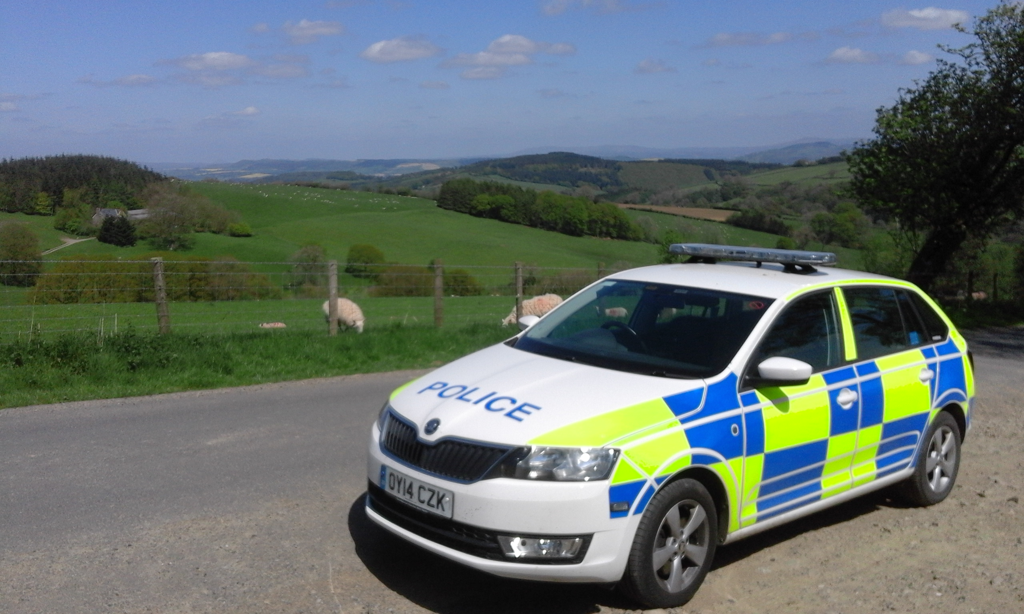

Surgeries/Event with Leominster SNT:

(There will always be an intention to attend and support these events, however due to the nature of policing, attendance by a member of the Team is not always guaranteed)

Leominster Library, The Buttercross, Town Centre

08/08/2016 – 10:30-11:30
15/08/2016 – 10:30-11:30
22/08/2016 – 10:30-11:30

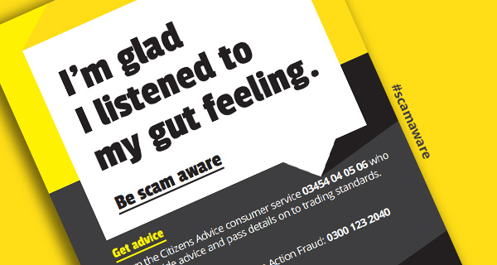

Action Fraud is supporting Scams Awareness Month - a national campaign launched by Citizens Advice to help people avoid falling prey to scams. The campaign urges people to take three steps to avoid being ripped off - get advice, report them and tell others about it.Research conducted by Citizens Advice finds fraudsters are using a variety of tactics to get people to part with their cash, with people losing an average of £2,500.
Scam methods include Vishing whereby scammers cold-call people in a bid to get their bank details, and offers of fake services, such as telling people their computer has a virus which they can fix remotely. Investment scams carried the highest price tag, with people investing in fake diamonds or bogus stocks and shares losing of on average £20,000 each.

Spotting scams, a fraudster may:
- Contact you out of the blue.
- Make promises that sound too good to be true - if something sounds too good to be true it probably is.
- Ask you to pay for something up-front - for example, they'll ask you to pay a fee before you can claim a prize.
- Ask you to make a quick decision by saying things like ‘if you don’t act now you’ll miss out’. This puts you under pressure and doesn’t give you time to think.
- Be over-familiar and over-friendly with you.
- Tell you an offer has to be kept secret.
- Ask for your bank account details. Never give your bank details to people you don’t know, especially people you meet online.
- Give a mobile number or PO Box number as the contact for their company- these are easy to close and difficult to trace. It may be a sign that the company doesn’t exist or isn't legitimate. Check out the company's details with Companies House or look on the internet for more details about them.

If you think something might be a scam, don’t reply - then throw it away, delete it or hang up and get further advice. Please note that Action Fraud is not responsible for the content of external websites.

To report a fraud and receive a police crime reference number, call Action Fraud on 0300 123 2040 or use our online fraud reporting tool.

Sign up for free to Action Fraud Alert to receive direct, verified, accurate information about scams and fraud in your area by email, recorded voice and text message.

Regards,

Pete Knight

PCSO 6378

Leominster Safer Neighbourhood Team

