West Mercia Police
Leominster
Safer Neighbourhood Team (SNT)
Leominster.snt@westmercia.pnn.police.uk
November 2016

About your team:

Safer Neighbourhood Teams work with local people and partners to identify, tackle and solve issues that matter to the community where you live.

Making neighbourhoods safer by cutting day to day crime and anti-social behaviour is at the heart of keeping people in West Mercia safe. Thanks to an investment in mobile tablet style computers, these will enable officers to spend more time on patrol on the street and in neighbourhoods.

Officers will continue to come to people when they need them and provide a high quality service however you contact us - in person (on the street, at community bases and at partners and communities together [PACT] meetings), on the phone or online.

Where we work:
Leominster SNT is based at Enterprise Way, Enterprise Park, Leominster, HR6 0LZ.
We work around the areas of:
Leominster, Ivington, Brierley, Brimfield, Little Hereford, Orleton, Ashton, Eye, Middleton-on-the-Hill, Kimbolton, Leysters, Byton,
Moreton, Luston, Norton, Yarpole, Eyton, Yatton, Kingsland, Wigmore, Aymestrey, Leintwardine, Kinsham, Lingen, Willey, Combe Moor, Combe,
Burrington, The Hundred, Richards Castle, Lucton, Leinthall Starkes, Leinthall Earls, Elton, Walford, Brampton Bryan, Downton, Byton,
Adforton, Leintwardine, Burrington, Stapleton,

Get in touch
 101 to talk to your local SNT or report a crime.
 Leominster.snt
@westmercia.pnn.police.uk
✓ www.westmercia.police.uk

/ @NHfdShireCops
Only call 999 in an emergency, when a crime is in progress or life is in danger.

Your team:

Andy Scott (Sergeant)
CHRIS O’DONOVAN (CONSTABLE)
PETE KNIGHT (PCSO)
GARETH MADDOX (PCSO)
ADAM MICHNIOK (PCSO)

For October 2016:
You said your priority was: | Anti social behaviour in Gas Works, Central, Etnam St, Spar Car parks. Vehicles congregating within the car parks, causing anti social behaviour and leaving litter.
Date set:  Date completed: | 01/08/2014  01/06/2016
We undertook: | - High visibility patrols by the safer neighbourhood team with a view to disrupting this behaviour, identifying persons responsible and dealing with them accordingly.  - Several council exclusion letters from the car parks have been served on drivers, conducting the above behaviour.  - Update 06/11/2016  - Continued patrols at areas of concern. SNT will continue to deal with those individuals concerned by way of warning letters.
You said your priority was: | Anti Social Behaviour and Criminal Damage to properties on the Barons Cross Estate, Leominster
Date set: | 01/10/2014
We have undertaken: | - High visibility patrols conducted by the Safer Neighbourhood Team.  - House to House surveys conducted by the Safer Neighbourhood Team in the area.  Update 06/11/2016  Patrols have continued in areas of concern. The SNT will continue to deal robustly with Offenders identified causing Anti Social Behaviour and Criminal Damage.

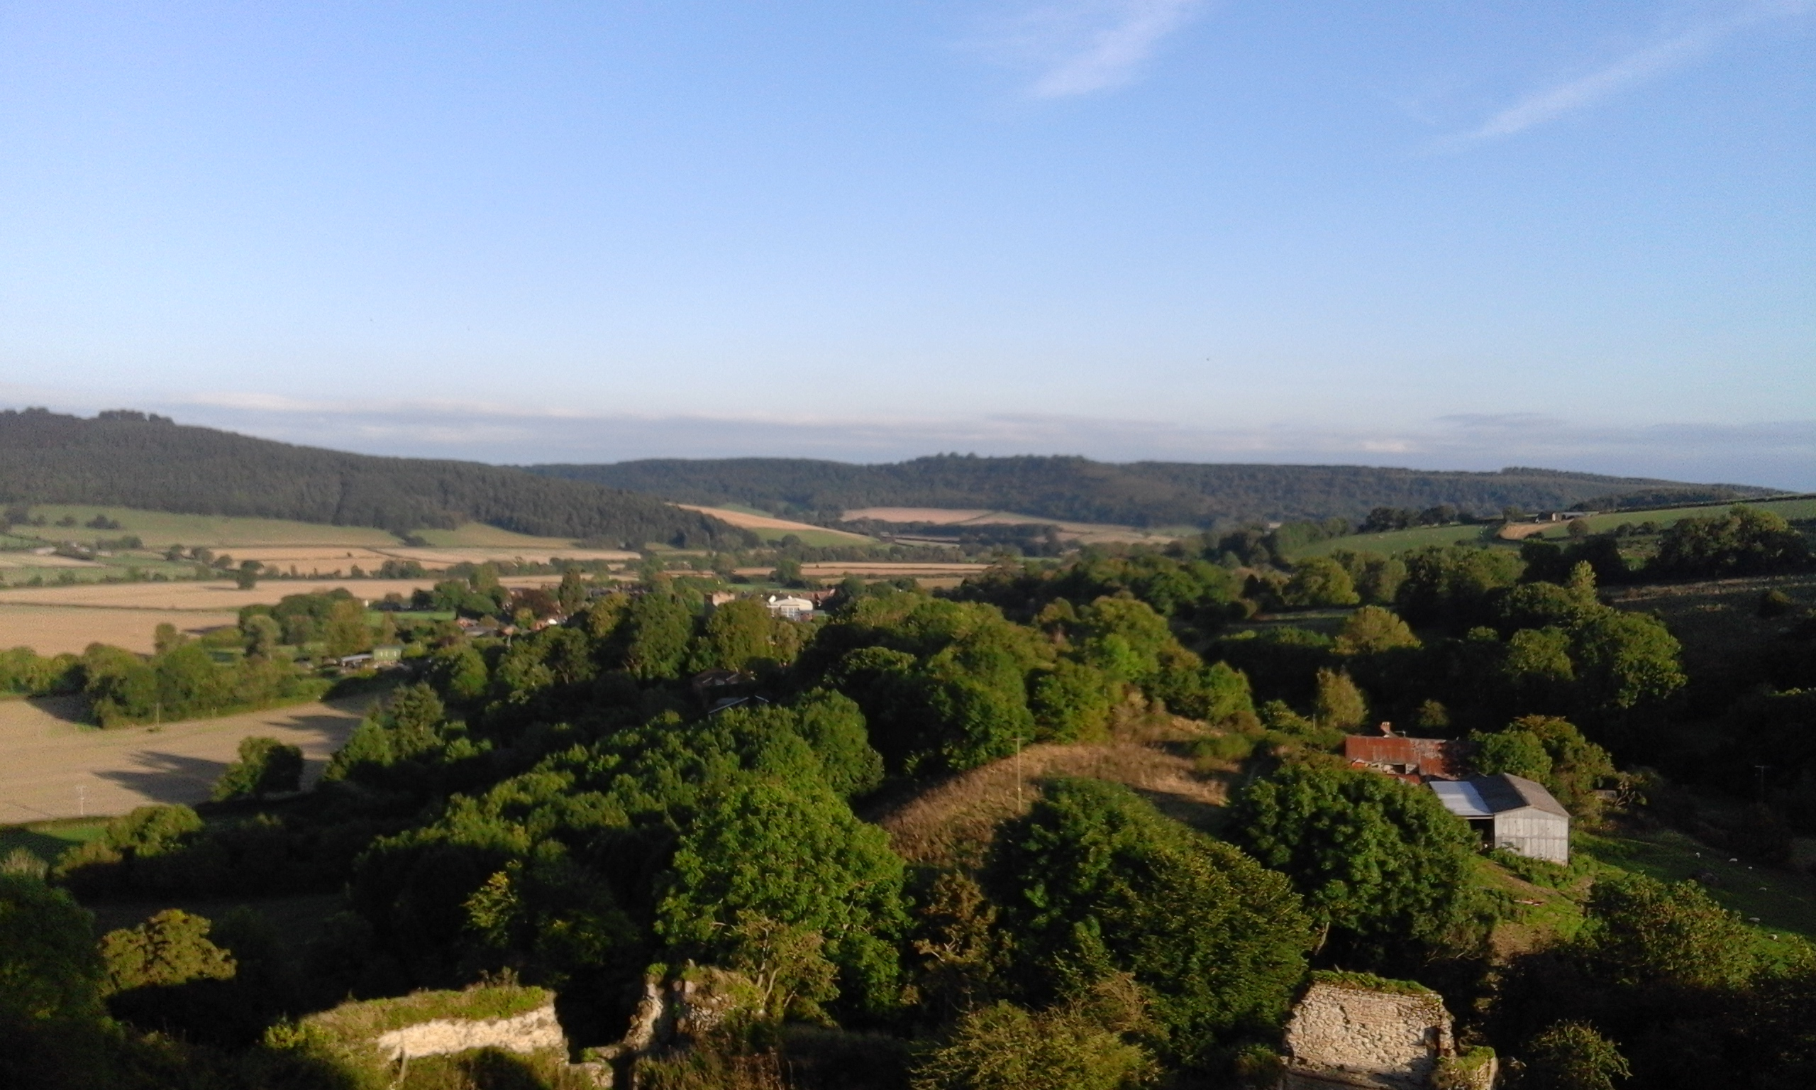

Firstly, some good news to report. The Safer Neighbourhood Team were out on foot patrol early on Halloween, to prevent and deter the minority of individuals looking to cause problems. I am happy to report that, as a result of this, only one incident of anti-social behaviour was received by us on the night.

The Team were at Travis Perkins in Leominster on the morning of 04/11/2016 offering to security mark items of property. The service offered is free and several customers arriving at Travis Perkins took advantage of it. The aim is to permanently mark items such as tools with either the owner’s business name or postcode which acts as a deterrent to thieves. Crime prevention advice was also on hand. Our thanks go to staff at Travis Perkins for making the event possible. We plan to hold further events like this and these will be publicised via newsletters and the website so watch this space!

We are receiving complaints regarding the manner of parking outside Schools by a small number of motorists either dropping Children off or collecting them later in the day. The nature of these complaints centre around parking on white zig zag lines, parking on pavements and in some cases, obstructing driveways. If you are taking Children to School please park responsibly and lawfully. Members of the Safer Neighbourhood Team are stepping up patrols at key times and whilst advice may be offered in some cases, enforcement will be considered.

The West Mercia Police area and especially North Herefordshire remains low crime. That said a number of incidents have occurred during the month and I would ask you to have a look at these to see if you could help with any information which may assist us in bringing the offenders to justice. Let me know if you need any crime prevention advice.

For daily updates on incidents in your area register for our Dotmailer service via www.westmercia.police.uk.

Should you wish to review crime and anti-social behaviour trends in your area over a longer period this can be done by visiting www.police.uk

Leominster

Burglary – An unoccupied property in Woodfen Crescent was broken into sometime between 17:00 26/10/2016 and 11:30 29/10/2016. The offender(s) gained entry via a side gate and then forced open a window. A quantity of jewellery was stolen from within. Incident 318S 291016.

Burglary – Sometime between 07:35 08/10/2016 and 08:45 10/10/2016 a shop premise in Drapers Lane was broken into. The offender(s) have stolen a quantity of cash from a cash box. Incident 53S 101016.

Orleton

Theft – A shed was broken into at a property in Mortimer Drive sometime between 09:30 19/10/2016 and 09:00 20/10/2016. A petrol strimmer was stolen from within. Incident 151S 201016.

Kimbolton

Theft – A detached garage at a property was broken into sometime between 20:00 06/10/2016 and 08:30 07/10/2016. A lawn mower was stolen from inside. Incident 124S 071016.

Richards Castle

Theft – An outbuilding was broken into at a property in the village. Tools were stolen from inside. Incident 123S 171016.

If you have any information regarding any of the above you can contact Leominster Police on 101, in an emergency please dial 999. Please be aware that any information provided within this newsletter is to inform you of incidents of note and to request possible assistance. We do not wish to worry you in anyway. Any incidents stated are infrequent and spread about a wide area. Herefordshire is a safe place to live!

Take a few simple steps to avoid becoming a victim of burglary.

1. Set a timer switch to turn your lights on when it gets dark – unlit houses are a give away that no one is home.

2. Lock your doors, patios and downstairs windows-even when you are in. Make sure you double check them again before you go to bed.

3. If you have a burglar alarm, make sure you set it when you go out and also when you go to bed.

4. Don’t leave car keys, ID cards or valuables near windows, doors or letterboxes, where burglars can reach through to steal them.

5. Lock your garden gates and side entrances. Don’t leave tools lying around in the garden which could be used to break into your home.

If you would like a member of the Safer Neighbourhood Team to visit you regarding home security advice please get in touch, either by calling 101 or sending an email to the Team at Leominster.snt@westmercia.pnn.police.uk.

We have been made aware of some incidents of cold calling, whereby individuals have been calling at properties either offering services or collecting on behalf of charities. Whilst the vast majority of these callers are genuine we must reinforce the message that you should not allow anyone into your property unless you are certain that they are genuine. Check their identification whilst they remain outside and contact the organisation that they claim to represent to confirm their identity. Genuine callers will never object to you doing this. If you receive a call that you suspect may not be genuine please contact Police immediately.

Surgeries/Event with Leominster SNT:

(There will always be an intention to attend and support these events, however due to the nature of policing, attendance by a member of the Team is not always guaranteed)

Leominster Library, The Buttercross, Town Centre

07/11/2016 – 10:30-11:30
14/11/2016 – 10:30-11:30
21/11/2016 – 10:30-11:30
28/11/2016 – 10:30-11:30

Yarpole Coffee in the Church

15/11/2016 – 11:00

Wigmore Community Shop

07/11/2016 – 10:00

Brimfield Village Hall Coffee Morning

17/11/2016 – 11:00

Orleton Village Hall Coffee Morning

16/11/2016 – 10:30

Richards Castle Village Hall Coffee Morning

16/11/2016 – 11:30

Regards,

Pete Knight

PCSO 6378

Leominster Safer Neighbourhood Team

