West Mercia Police
Leominster
Safer Neighbourhood Team (SNT)
Leominster.snt@westmercia.pnn.police.uk
March 2017

About your team:

Safer Neighbourhood Teams work with local people and partners to identify, tackle and solve issues that matter to the community where you live.

Making neighbourhoods safer by cutting day to day crime and anti-social behaviour is at the heart of keeping people in West Mercia safe. Thanks to an investment in mobile tablet style computers, these will enable officers to spend more time on patrol on the street and in neighbourhoods.

Officers will continue to come to people when they need them and provide a high quality service however you contact us - in person (on the street, at community bases and at partners and communities together [PACT] meetings), on the phone or online.

Where we work:
Leominster SNT is based at Enterprise Way, Enterprise Park, Leominster, HR6 0LZ.
We work around the areas of:
Leominster, Ivington, Brierley, Brimfield, Little Hereford, Orleton, Ashton, Eye, Middleton-on-the-Hill, Kimbolton, Leysters, Byton,
Moreton, Luston, Norton, Yarpole, Eyton, Yatton, Kingsland, Wigmore, Aymestrey, Leintwardine, Kinsham, Lingen, Willey, Combe Moor, Combe,
Burrington, The Hundred, Richards Castle, Lucton, Leinthall Starkes, Leinthall Earls, Elton, Walford, Brampton Bryan, Downton, Byton,
Adforton, Leintwardine, Burrington, Stapleton,

Get in touch
 101 to talk to your local SNT or report a crime.
 Leominster.snt
@westmercia.pnn.police.uk
✓ www.westmercia.police.uk

/ @NHfdShireCops
Only call 999 in an emergency, when a crime is in progress or life is in danger.

Your team:

Andy Scott (Sergeant)
CHRIS O’DONOVAN (CONSTABLE)
PETE KNIGHT (PCSO)
GARETH MADDOX (PCSO)
ADAM MICHNIOK (PCSO)

For February 2017:
You said your priority was: | Anti social behaviour in Gas Works, Central, Etnam St, Spar Car parks. Vehicles congregating within the car parks, causing anti social behaviour and leaving litter.
Date set:  Date completed: | 01/08/2014  01/06/2016
We undertook: | - High visibility patrols by the safer neighbourhood team with a view to disrupting this behaviour, identifying persons responsible and dealing with them accordingly.  - Several council exclusion letters from the car parks have been served on drivers, conducting the above behaviour.  - Update 02/03/2017  - No further problems to report at present. The Team will however continue to undertake patrols of areas listed.
You said your priority was: | Anti Social Behaviour and Criminal Damage to properties on the Barons Cross Estate, Leominster
Date set: | 01/10/2014
We have undertaken: | - High visibility patrols conducted by the Safer Neighbourhood Team.  - House to House surveys conducted by the Safer Neighbourhood Team in the area.  Update 02/03/2017  Patrols are continuing in areas of concern. The SNT are continuing to deal robustly with Offenders identified causing Anti Social Behaviour and Criminal Damage on the Barons Cross Estate. A number of warning letters have been served on youths identified.
You said your priority was: | Anti Social Behaviour, Criminal damage and reports of drug use in The Grange, Etnam Street Car Park, Sydonia and The Priory with surrounding areas.
Date set: | 01/02/2017
We have undertaken: | High visibility patrols targetted in those areas by the SNT.

The West Mercia Police area and especially North Herefordshire remains low crime. That said a number of incidents have occurred during the month and I would ask you to have a look at these to see if you could help with any information which may assist us in bringing the offenders to justice. Let me know if you need any crime prevention advice.

For daily updates on incidents in your area register for our Dotmailer service via www.westmercia.police.uk.

Should you wish to review crime and anti-social behaviour trends in your area over a longer period this can be done by visiting www.police.uk

Leominster

Criminal damage – Sometime between 22:00 on 10/02/2017 and 09:00 11/02/2017 a vehicle parked in Oldfields Close was badly scratched and the tyres deflated. If you saw anything suspicious in the area around these times, please contact police on 101.

Criminal damage – An obscenity was sprayed onto the front of a property in Ridgemoor Road sometime after midnight on 15/02/2017. Incident 119S 150217.

Criminal damage – Sometime between 17:30 and 19:00 on 19/02/2017, an obscenity was written on the door of a property in Farmeadow Road. Incident 606S 190217.

Burglary – An unoccupied property in Stockenhill Road was broken into sometime between 14:30 and 20:30 21/02/2017. The offender(s) gained entry via a patio door at the rear. At this stage it appears that a quantity of jewellery has been stolen. Incident 689S 210217.

Burglary – A burglary was reported from a property in Clifford Road. This occurred whilst the occupant was away and is believed to have happened sometime between 11:00 25/02/2017 and 13:30 27/02/2017. Entry was gained via the rear of the property and a quantity of jewellery was stolen. Incident 341S 270217.

At around 16:00 on 08/02/2017, two youths with possibly irish accents attended a commercial premise in Etnam Street and have used a counterfeit Scottish £20.00 note to buy a low priced item. It is believed the same two may well have attended another commercial premise nearby and committed the same offence. Incident 461S 080217.

Luston

Theft – Sometime between midnight on 07/02/2017 and 15:00 on 09/02/2017 a 1000L water bowser and trailer were stolen from a field in the village. A vehicle would have been used in order to steal this item. Incident 353S 090217.

Burglary – Sometime between 16:00 and 18:00 on 20/02/2017, car keys were stolen from inside a property in the village. The vehicle, parked outside, was not stolen but if you saw any suspicious activity in the village around this time please contact Police. Incident 317S 210217.

Kingsland

Criminal damage – Damage was caused to a vehicle parked in the car park at the Doctors Surgery, sometime between 08:00 and 16:30 on 19/02/2017. The vehicle suffered some scratches. Incident 693S 210217.

Little Hereford

Burglary – A shed at a property in the village was broken into sometime between 09:30 and 22:30 on 07/02/2017. Although damage was caused to the lock, nothing appears to have been taken.

If you have any information regarding any of the above you can contact Leominster Police on 101, in an emergency please dial 999. Please be aware that any information provided within this newsletter is to inform you of incidents of note and to request possible assistance. We do not wish to worry you in anyway. Any incidents stated are infrequent and spread about a wide area. Herefordshire is a safe place to live!

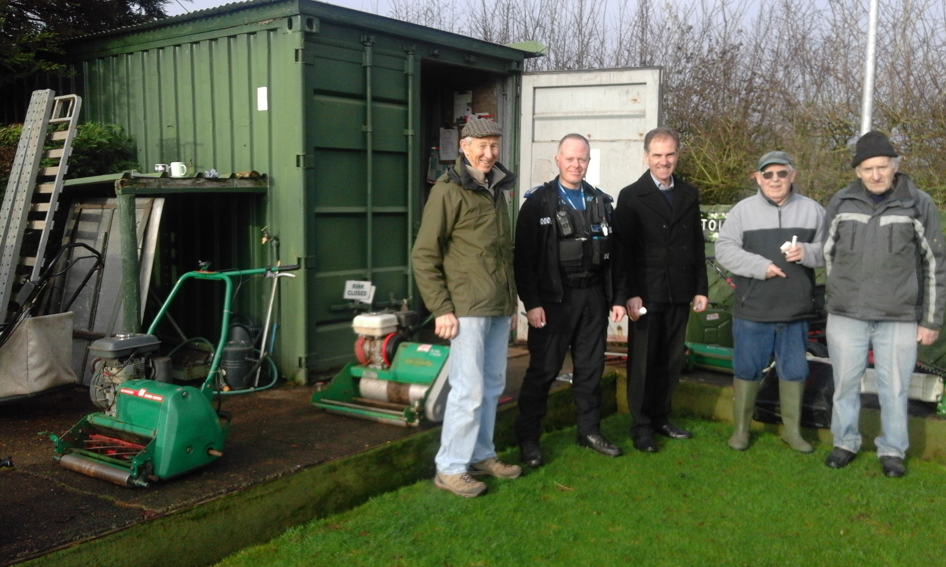

We recently attended a local organisation in order to mark a number of items of property. Marking items such as Mowers, tools etc can significantly reduce the risk of theft. If you are a member of an organisation or club and would like to take advantage of this service please contact us. We can also offer crime prevention advice and tips whilst there.
If you would also like a member of the Safer Neighbourhood Team to visit you regarding home security advice please get in touch, either by calling 101 or sending an email to the Team at Leominster.snt@westmercia.pnn.police.uk.

Tips to nip garden crime in the bud

With spring just around the corner many of us will soon be out in the garden. With this in mind it is timely to remind everyone about security around sheds and outbuildings. Although many people take steps to protect their homes and the property inside them, they leave valuable equipment in gardens and unsecured sheds, providing easy pickings for opportunist thieves.
Power tools, mowers, garden tools, mountain bikes and golf clubs are just some examples of expensive equipment left in sheds that are not strong or secure
enough to protect them from thieves. To make matters worse, these stolen items could then be used to break into your house.
Around 3000 shed burglaries take place every year within Warwickshire and West Mercia, which highlights the importance of storing valuable items securely.
Effective garden security covers everything from boundary fences and gates to the valuables stored inside your shed. Here are some tips on how you can ‘weed out’ garden thieves.

Defensive planting

Everyone enjoys having a well kept, attractive garden and there’s no reason why upping the security in your garden should mean otherwise. ‘Defensive planting’ is the term used to describe the way you can use certain prickly plants, bushes and shrubs to deter burglars. Examples include Berberis, Pyracantha and Holly. Many of these are good for hedges and growing near to walls. Ask for advice at your local garden centre. This green-leafed security measure is not meant to replace, but to complement other security measures, such as lighting, locks and alarms.
Think location, location, location! Think about using defensive planting around vulnerable areas such as windows, fences, boundary walls and drainpipes.

Don’t give thieves ‘shedloads’ of opportunities !

Most garden sheds are not designed for safe storage. Ideally, expensive items such as power tools, mowers, garden tools, bicycles and golf clubs should not be stored in them. However, you may have no alternative, in which case here are some shed security tips:

Keep your shed in good condition.
Fit a closed shackle padlock to the door.
Fittings should be bolted through the door and any screws concealed.
Fit grilles or mesh to the windows.
Invest in an alarm.
Once you’ve improved the physical security of your shed, it is important to make everything inside it secure. Tools and equipment could be used to force entry into your home, causing you even more expense and hassle.
Make sure large items such as bicycles are chained together. It is much more difficult for a thief to carry away a lot of large heavy items all at once. Ensure ladders are locked to a secure fixture in the shed or garage so they cannot be used to reach top floor windows of your house. Your valuables should also be marked with your postcode. A member of the SNT can visit you to do this.

Let there be light!

Well positioned external lighting is a great way of keeping intruders at bay and can be purchased from most large DIY stores.

Protecting your boundaries

The boundaries of your property are your first line of defence against burglars. Strong gates, fences and walls which are kept in good repair can deter intruders from getting to the back and sides of your property. Make sure:
Rear garden fences are high enough to make climbing them difficult. A trellis can be used to add additional height.
Side gates are positioned as close to the front of the house as possible. Thieves will be put off by the fact that they are in full view of the neighbours. Ensure gates are kept locked at all times.
For more garden security tips, visit our website which also provides crime prevention advice for your home and vehicle.

Door to door selling

A number of calls have been received regarding door to door selling. Please take a look at the following advice.

It is always advisable to use a chain or peephole before answering the door to anyone that you do not know.
If there is a person claiming to be from the electricity/gas/water company then they will have official ID. If they are genuine they will have no problems with you looking at it and telephoning the company to verify it. Look the telephone number up yourself, do not use a telephone number they give you as you cannot be sure that it is genuine.
If you have any doubts whatsoever then do not let them in, it is better to be safe than sorry. You can always then telephone the company and make an arrangement for another day.
If it is a person who wants to carry out some work on your garden/drive/roof and they make a cold call to your house then be very wary. Before having any major work done on the house, you need at least two or three quotes from different reputable companies.
If the person gives you a price that is too good to be true then it will be. Be careful there have been cases of people carrying out the job and then demanding more money.
There are also cases of the person offering to drive the occupant down to the bank to get the money, which is often at a massively inflated price.
Some people who offer to carry out such tasks are genuine but there are those that are not and will take advantage of people, mainly the vulnerable and the elderly. It is advisable not to allow any workmen to carry out any tasks in your home unless they have been personally recommended to you.
If the person keeps contacting you about the work then be very careful as reputable companies tend to be very busy and do not need to chase work.
Local council building control can advise on building contractors on an "approved list". Also Trading Standards can advise on other contractors (for example burglar alarm installers). Also trade associations often have lists of "registered" businesses. Plus ask the caller at the door for a card, website address, names and addresses of local premises where he/she has undertaken work (and contact one or two of them to verify personally).
See the website in related information for more help and advice or contact Consumer Direct on: 08454 040506.

Surgeries/Event with Leominster SNT:

(There will always be an intention to attend and support these events, however due to the nature of policing, attendance by a member of the Team is not always guaranteed)

Leominster Library, The Buttercross, Town Centre

06/03/2017 – 10:30-11:30
13/03/2017 – 10:30-11:30
20/03/2017 – 10:30-11:30
27/03/2017 – 10:30-11:30

Yarpole Coffee in the Church

24/03/2017 – 11:00

Wigmore Community Shop

16/03/2017 – 11:00
Orleton Village Hall Coffee Morning

15/03/2017 – 11:00

Leintwardine Library

28/03/2017 – 14:00

Regards,

Pete Knight

PCSO 6378

Leominster Safer Neighbourhood Team

